**Peer Evaluation Form–Project - Checkpoint/Final Report (indicate) ______________________**

Your name ____________________________________________________ Team name (if any)__________________________________________________

Write down the names of each team member in the following table and follow the instructions to distribute the points:

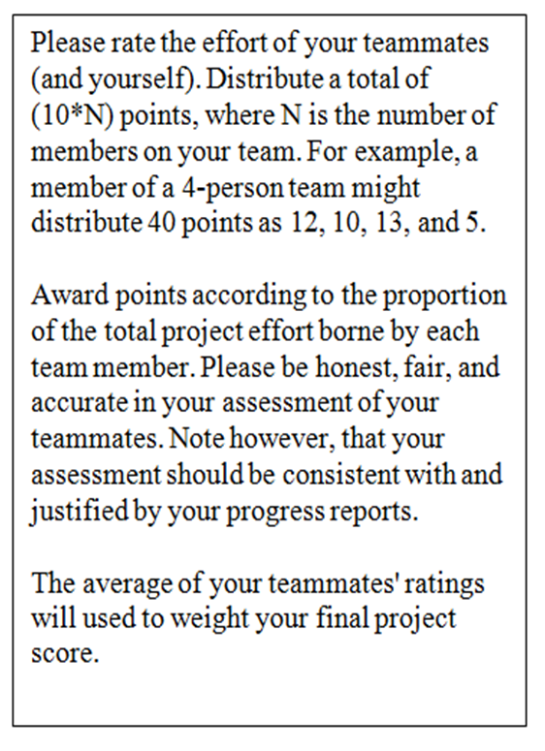

|  |  |  |
| --- | --- | --- |
| **Team member names** | **Role** | **Rating** |
| **You:** |  |  |
| **#1:** |  |  |
| **#2:** |  |  |
| **#3:** |  |  |
| **#4:** |  |  |
| **#5:** |  |  |
| **TOTAL ( = # members * 10)** |  |  |

NOTE: Name file as Checkpoint#_PeerEvaluation (# according to checkpoint number)

**Comments regarding to your Peer Evaluation (explain any great thing or any difficulty about the project) :**